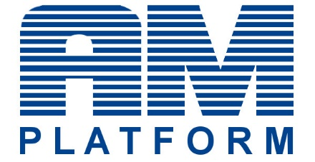
Letter of Support - European AM Skills Strategy

We do appreciate that the project SAM (Sector Skills Strategy in Additive Manufacturing) project, aims to deliver together with all partners and stakeholders a shared vision and collaborative skill solutions capable to foster and support the growth, innovation and competitiveness in the Additive Manufacturing (AM) sector.
We agree with the identified gap drivers AM related and support the developed strategy for the sector and it’s implementing activities foreseen in the AM Skills Strategy Roadmap 2021 – Overview on challenges and action document achieving the following expected results:
1) Reduce the skills gaps and ensure alignment between the training offers and the industry needs
2) Increase the number of AM Qualified personnel, being by re-skilling, up-skilling of by training the “new” workforce
3) Facilitate the access of professionals, students and industry to AM training
4) Wider pool of qualified personnel that can “move” between different countries and industrial sectors
5) Improved foresight of skills needs for the AM Sector
6) Increase the number of people/students trained in AM in the short and long term across Europe
7) Greater access to funding to support AM-related skills development and sustainment
As our organisation strongly believes in the proposed strategy for Personnel Skills and Qualifications in AM, we hereby subscribe this letter allowing that the company name is listed as one of the organisations supporting this strategy.

_________________
(Date and Place)

______________
(Company logo and Name)

_________________
(Signature)

